# Practical 7

Aditya Sharma

Sec-A

Roll: 10

**User Report:**

* **Content:** Details user profiles, including their roles, contact information, and login history.
* **Purpose:** Offers administrators an overview of the user base, aiding in user management and access control.

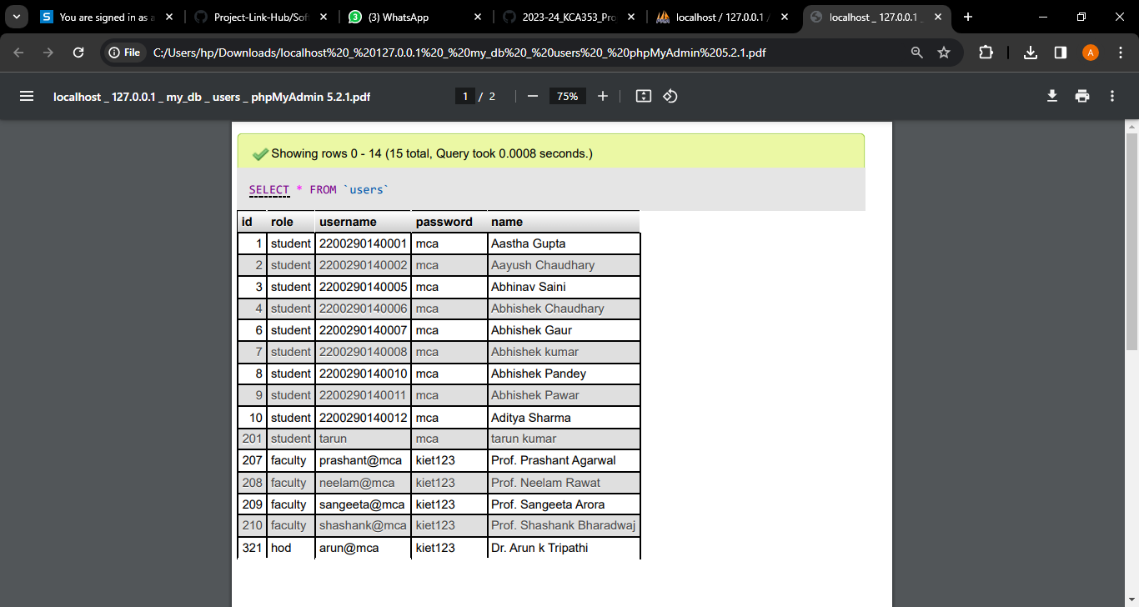

**Project Report:**

* **Content:** Summarizes essential details of all projects, such as project title, objectives, faculty in charge, and status.
* **Purpose:** Provides a comprehensive overview for faculty and administrators to manage and evaluate the overall project landscape.

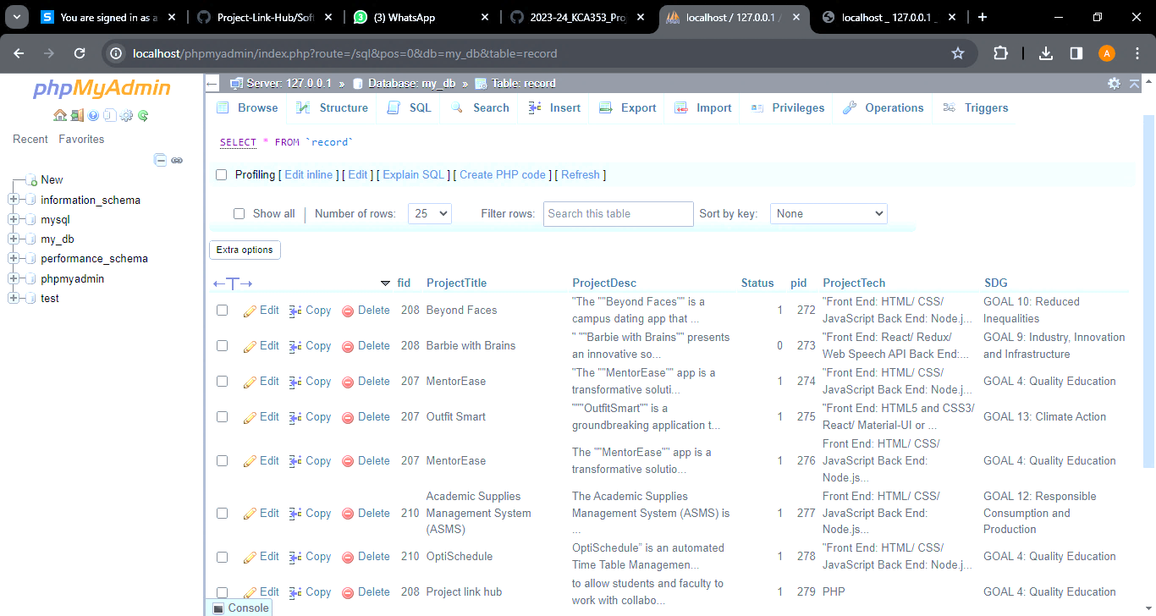

**Student Report:**

* **Content:** Presents information about individual students, including their details, enrolled projects, and overall project involvement.
* **Purpose:** Assists faculty members in understanding each student's engagement and contributions to different project

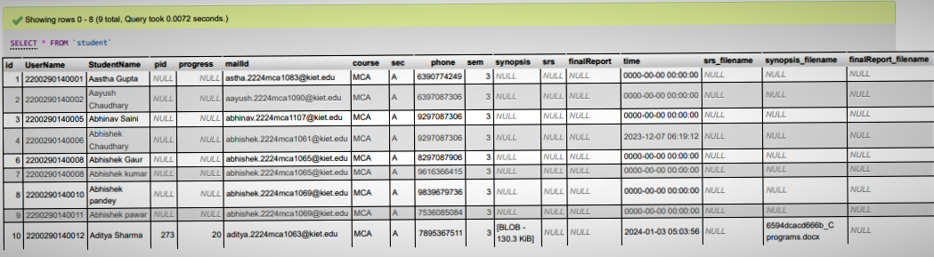

**Project Assigned Report:**

* **Content**: Highlights projects allocated to specific students, including project details and current progress.
* **Purpose**: Enables faculty members to efficiently track and manage project allocations, ensuring an equitable distribution of projects among students.

